EXPERIMENT NO : 1
ROLL NO : 240701430 NAME : RITHIKA L

Comparative Study of Low-Code Development versus Traditional Application Development Approaches

1. Aim
To perform a comparative study between traditional application development and low-code development by understanding their workflow, architecture, coding effort, development speed, cost, deployment, maintenance and practical applications.

2. Introduction to Traditional Application Development
Traditional application development is the conventional software development methodology in which programmers build applications by writing source code using programming languages such as Java, Python, C#, JavaScript and PHP. It follows the Software Development Life Cycle (SDLC) comprising requirement analysis, system design, coding, testing, deployment and maintenance. This approach offers complete flexibility, scalability and security but requires experienced developers, longer development time and higher development cost. It is widely used for enterprise applications that demand complex business logic and extensive customization.

3. Introduction to Low-Code Development
Low-code development is a modern software development approach that enables developers to build applications using visual interfaces, drag-and-drop components, reusable templates and workflow automation with minimal coding. It accelerates application development, reduces cost, improves productivity and simplifies deployment. Platforms such as Zoho Creator, Microsoft Power Apps, Mendix and OutSystems enable rapid development while maintaining reliability.

4. Flowchart – Traditional Application Development
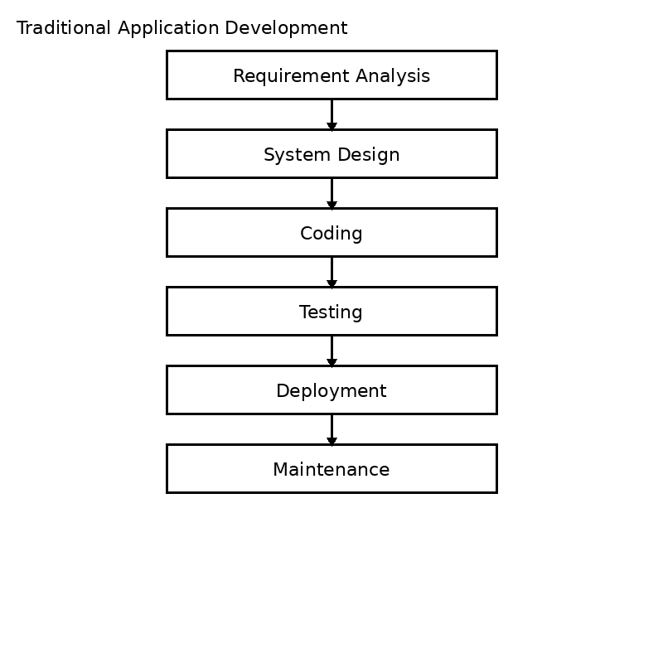

5. Flowchart – Low-Code Development
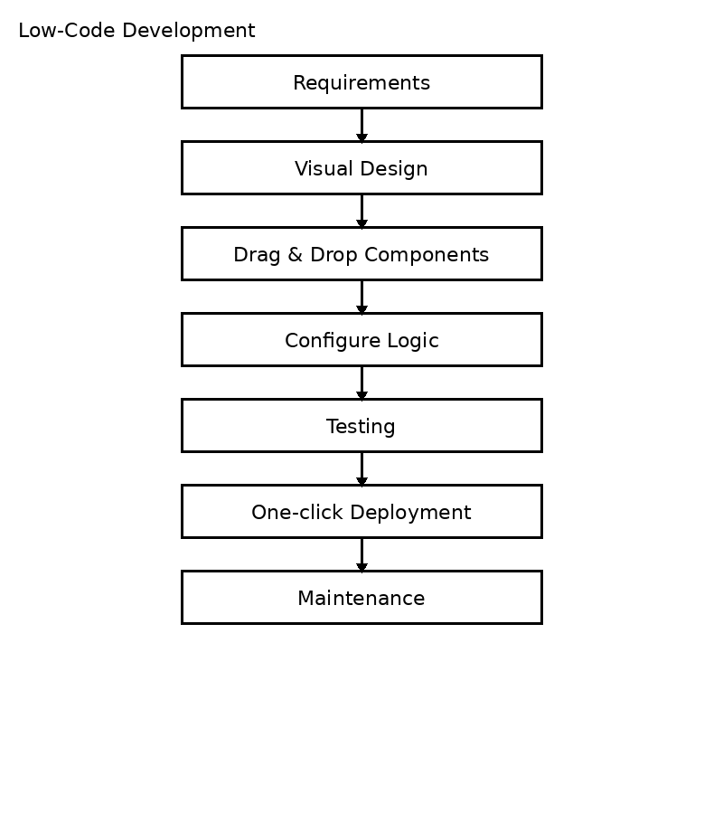

6. Comparative Analysis
Parameter | Traditional | Low-Code
Coding | Extensive | Minimal
Development Time | Long | Short
Cost | High | Low
Customization | Very High | Moderate-High
Deployment | Manual | One-click
Maintenance | Complex | Easy
Users | Professional Developers | Developers & Citizen Developers
Scalability | Excellent | Good
Productivity | Moderate | High
Best Use | Complex Systems | Business Apps

7. Result
Low-code development significantly reduces application development time, effort and cost while improving productivity. Traditional development remains the preferred approach for highly customized and large-scale applications requiring complete control over the software architecture.

